MINISTRY OF EDUCATION AND SCIENCE OF UKRAINE

**KHARKOV NATIONAL UNIVERSITY OF**

**RADIOELECTRONICS**

**Subject: internet technology**

### Student:julio jubran

### Foresight Ovvіomodіovho CourseChief: Ganna Zavolodko

Group: KIYKLIB-18-1

**2021**

Car list

1.Website Design Goals and Objectives:

To create information resource about modern ecological car!

1. to create a car website.
2. To have it publish in this next month.
3. To make it with html and css style.

2.Specific features of future visitors.

|  |  |  |  |  |
| --- | --- | --- | --- | --- |
| URL | Design | Color | Content | Menu |
| https://www.ferrari.com/ | Interactive | Black+red | Minimalizm | Up inline |
| https://avto-russia.ru/autos/ferrari/ | minimalizm | Black_white | Block elements | Up inline |
| https://grubier.com/en | Classical | Gray_white | Portfolio | Up image |
| For brief | Interactive | White+red | Block elements | Up inline |

The best analog is https://www.ferrari.com/

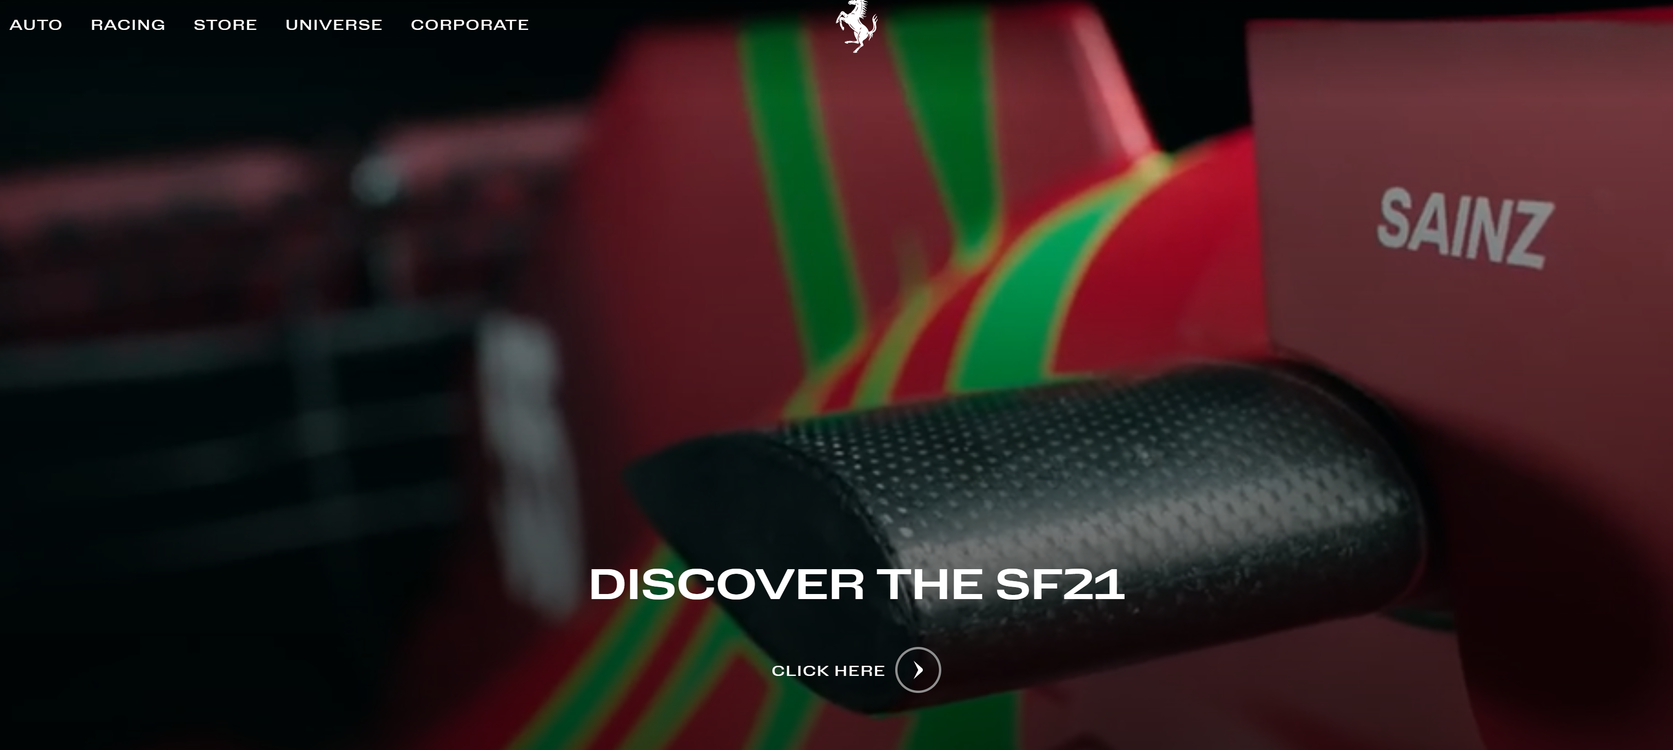

To design a website which show the visitors the cars which they like and to let them know about this car more details before to buy it.

To let them imagine their future car and to know about it before.

3. Website design brief for our Ferarri website .

Target audience

Our target audience is mainly for those who can afford the luxury life and love fast and premium cars.

1.Our audience types-Most **Ferrari's** customer is rich businessmen and first class people.

1. Buyer audience- the wealthy in our society and who have high paying jobs that the total cost of the car does not exceed their two month salary.
2. Key motivation- to give our clients the best quality of cars, and to be sure, we give them their dream car.
3. Key issues-we can bring our clients dream car to reality.
4. Characteristics- we have our dealer ships nation wide,and also one can order his choice of brand from our catalouge and get delivered home.

6.demographics- we don’t have a specific gender, but our community have a lot of people who around 25-60 years old .

1. Structure of the future site. (map of sites: physical structure, logical structure)
2. to try and help the visitors to buy the most ideal car for them.
3. Communication between the visitors and the site itself.
4. Innovation always.
5. Collaborating with each others.
6. general design concept, and the style.

My design for the website is to show the advantages things for my clients and try to sell them the cars which they choose, and to make a connection between them and the car itself before to buy it .

The style will be dynamic with some animation , and an attractive cars inside it .

The map of our website

-

1. Home page->forsaiyth
2. Blog.->forsaiyth
3. Services.->forsaiyth/julio
4. About.->julio
5. Contact.->julio
6. modular grid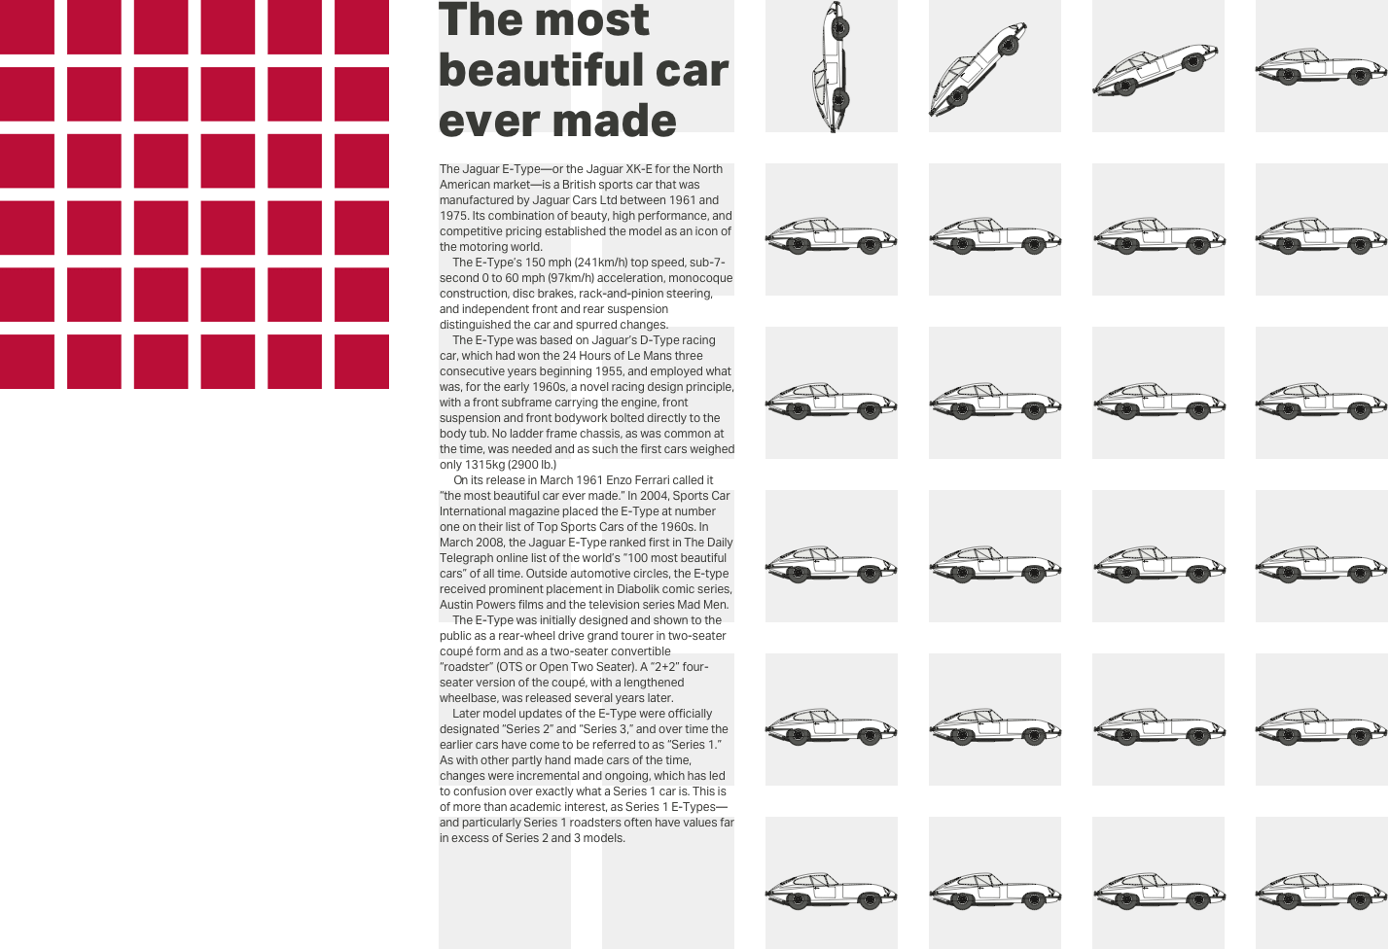

6.Content plan

Step 1: [Determine the Purpose of the Website](https://blog.alexa.com/the-complete-guide-how-to-write-content-for-a-website/" \l "purpose)

Step 2: [Research the Audience](https://blog.alexa.com/the-complete-guide-how-to-write-content-for-a-website/" \l "research-audience)

Step 3: [Research Competing Websites](https://blog.alexa.com/the-complete-guide-how-to-write-content-for-a-website/" \l "research-competition)

Step 4: [Plan How the Content Fits Together on Your Website](https://blog.alexa.com/the-complete-guide-how-to-write-content-for-a-website/" \l "content-plan)

Step 5: [Write the Content for Each Page](https://blog.alexa.com/the-complete-guide-how-to-write-content-for-a-website/" \l "writing)

Step 6: [Add Non-Copy Page Elements](https://blog.alexa.com/the-complete-guide-how-to-write-content-for-a-website/" \l "non-copy-elements)

Step 7: [Make Edits](https://blog.alexa.com/the-complete-guide-how-to-write-content-for-a-website/" \l "editing)

Step 8: [Plan to Update Content Later](https://blog.alexa.com/the-complete-guide-how-to-write-content-for-a-website/" \l "plan-updates)

1. Register your domain name: **Ferrari_info.con**

2. Find a web hosting.

3. Prepare your content.

4. Build your website.

1. Essey for my website.

* Provide a Description of the Site Is for:to make a website which describe the car in more deep details for the clients.
* Come Up With a **Website**/Project Overview:a new website which we build from scratch.
* Define the Project's Goals: the goals to sell more cars for clients who wish to have our cars, and to develop it fast and with a high quality.
* Identify the Site's Target Audience:our target audience is to make it easier for the clients to buy our cars, and to let them feel relief and important for us .
* Research Competitors.: to make a research for our competitors and look at th @VAZartLearning/nure e different between the idea of our goals.
* Write Effective Content